
Methods 11 Test 1 2017
Indices, Exponential Equations, Significant Figures
Time Allowed: 55 minutes Total Marks: 52
Name: _______________________
Resource Free

ALL working must be shown for full marks.

1. [2, 3, 3, 3 = 11 marks]

Write each in simplest form with positive indices.

a) 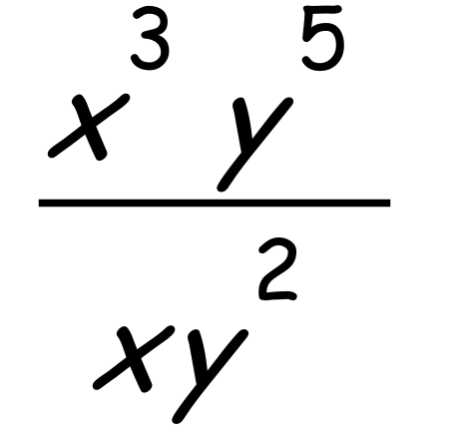 b) 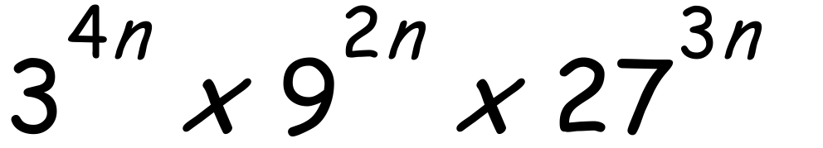

c) $\frac{{\text{3}}^{\text{n+2}}\text{+27}}{\text{5 x }{\text{3}}^{\text{n}}\text{+15}}$ d) 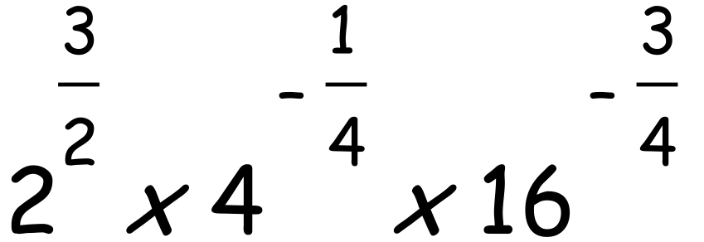

2. [4, 3, 3, 3 = 13 marks]

Solve the following exponential equations:

a) 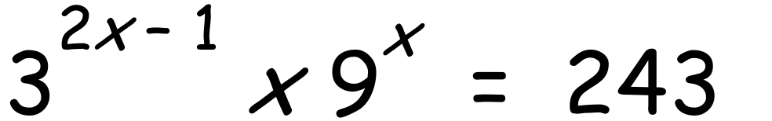 b) 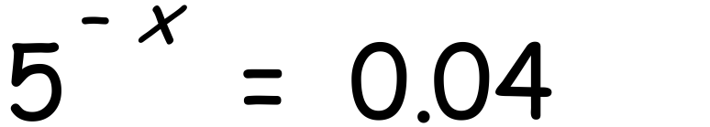

c) 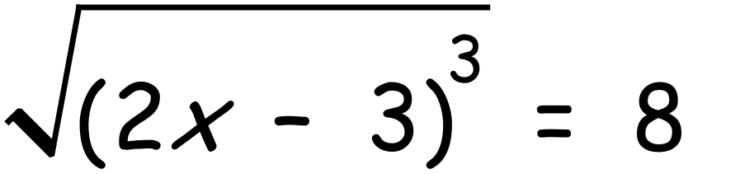 d) 2$\sqrt[3]{x=12 }$

3. [2, 3 = 5 marks]

Estimate the numerical value of the following by rounding to one significant figure:

a) 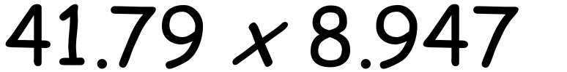 b) 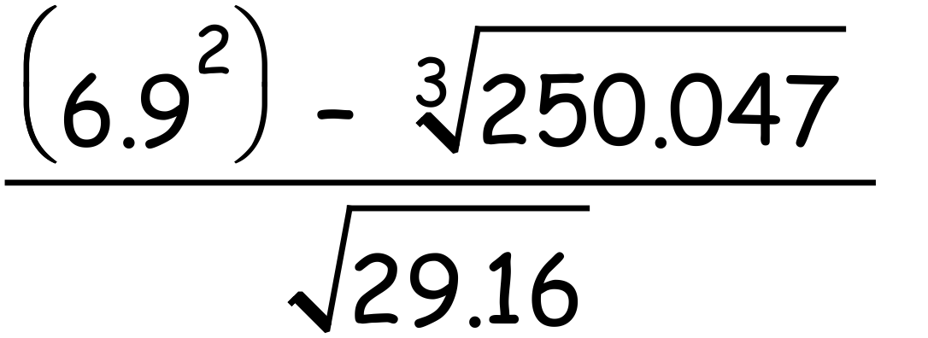

4. [3, 2, 2, 2 = 9 marks]

Given that 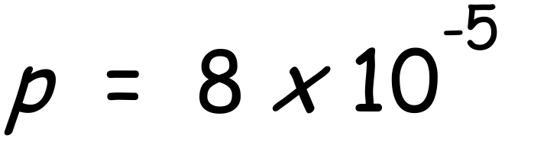 , $\text{q=2 x }{\text{10}}^{\text{4}}$ and $\text{r=3 x }{\text{10}}^{\text{-2}}$ , determine each of the following giving exact answers in standard form.

a) pqr b) 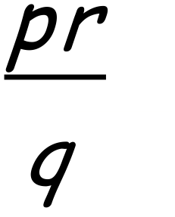

c) p – r d) q + p

5. [4 marks]

Write each number in scientific notation correct to 3 significant figures.

a) 251 000

b) 4 827 000

c) 0.00708

d) 3 millionths

6. [4, 6 = 10 marks]

Simplify:

a) 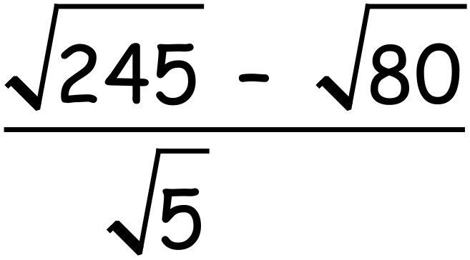 b) $\frac{{\text{3}}^{\text{3x}}\text{- }{\text{9}}^{\text{x+1}}}{\text{1- }{\text{3}}^{\text{2-x}}}$

